**An analysis based on Cereal data**

**Introduction**

In the United States, cereal is a common morning food, and the cereal sector contributes significantly to the nation's food economy. Many cereal brands and variations, from sweet and sugary to healthy and nourishing ones, are offered in the United States. The first cereal brands were established in the late 19th century, beginning a lengthy history for the cereal industry in the United States. People of all ages like cereal, which is a mainstay in many American homes today. Because to intense competition, manufacturers continuously release new cereal tastes and kinds to satisfy customer demand.

**Dataset Description**

The data utilized for this analysis is based on cereal data, which comprises 77 rows and 15 columns. The columns represent the cereal, manufacturer, type, and the ingredients of cereals. The rows indicate the 77 different varieties of cereals that people usually have for breakfast (as shown in figure 1). Figure 1 shows an illustration of the cereal dataset as an example for easier comprehension. The following provides an explanation of the dataset's keywords and units for cereal substances.

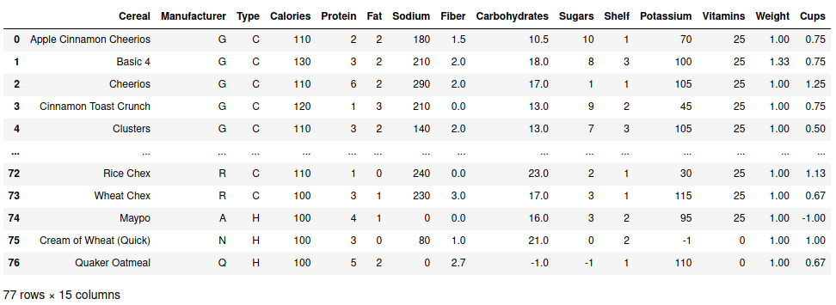Figure 1: The dataset of the cereals

Several manufacturers were represented in the dataset using letters such as A, G, K, N, P, Q, and R.

The abbreviations are as follows:

A = American Home Food Products

G = General Mills

K = Kelloggs

N = Nabisco

P = Post

Q = Quaker Oats

R = Ralston Purina

There are two letters, such as C and H, in the type column that categorize the cereals into two groups. They are:

C = Cold

H = Hot

The units for the ingredients and other items in cereals are given below.

Calories = the amount of calories per serving

Protein = grams (g) of protein contains in a cereal

Fat = grams (g) of fat contains in a cereal

Sodium = milligrams (mg) of sodium contains in a cereal

Fiber = grams (g) of fiber contains in a cereal

Carbohydrates = grams (g) of carbohydrates contains in a cereal

Sugars = grams (g) of sugars contains in a cereal

Potassium = milligrams (mg) of potassium contains in a cereal

Vitamins = vitamins & minerals (0, 25, or 100, respectively indicating 'none added'; 'enriched, often to 25% FDA recommended'; '100% of FDA recommended')

Weight = in ounces in one serving

Cups = cups per serving

The shelf column in the data shows the location on the shelf where a cereal was kept. There are three shelves in all, and each one holds a different proportion of the total number of cereals.

**Methodology**

The entire analysis was carried out on the Python platform, using "miniconda" for managing Python packages, "pandas" for data analysis, "numpy" for performing mathematical operations on arrays, "statistics" for performing statistical calculations, and "matplotlib" for visualizing the data and graphical plotting. The coding, however, was carried out on a "Jupyter notebook". The conda package manager was first used to install the necessary items. After that, Jupyter notebook imported the library files. The data was then read using pandas, and any discrepancies in the dataset were examined. Since it is discovered that the dataset contains a small number of negative values. In order to replace these values, the negative values were deleted and the mean values for the appropriate column were used instead. Afterwards, for additional purpose, the revised dataset was exported. Ultimately, several comparisons and analyses were carried out using the Python programming language. To obtain the appropriate output from the dataset, the matplotlib, numpy, and statistics commands were utilized. The updated dataset is displayed below in figure 2.

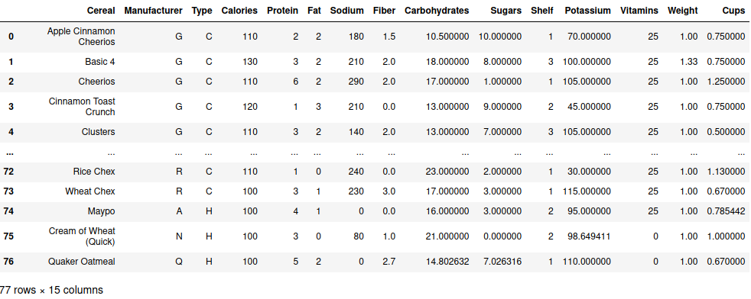Figure 2: The dataset after the modification

**Results & Discussion:**

After analyzing the data, some important comparison were made though there were many possibilities for making more comparison with the data. The findings of this analysis is presented below.

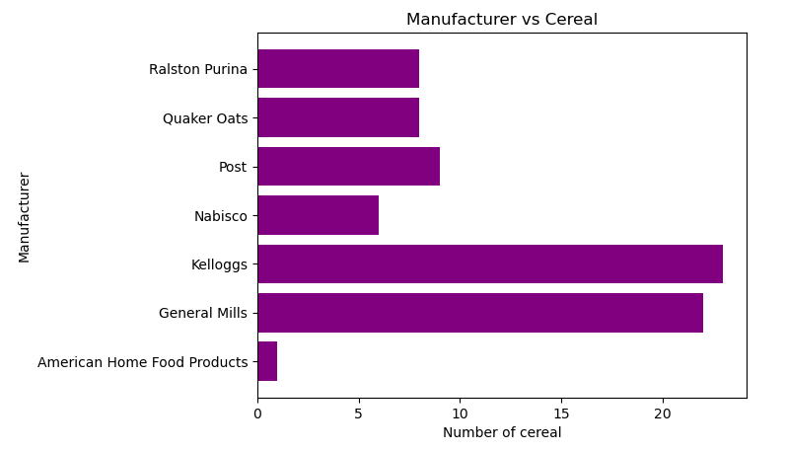

Figure 3: The number of different cereal production against different manufacturer

Figure 3 shows the many cereal varieties supplied by the various producers. The most cereal varieties are offered by Kellogg's and General Mills, both of whom have more than 20 varieties. Other than "American home food products," the producer offers a variety of cereal in the price range of 5–10. The sole cereal offered by "American home food products" is one.

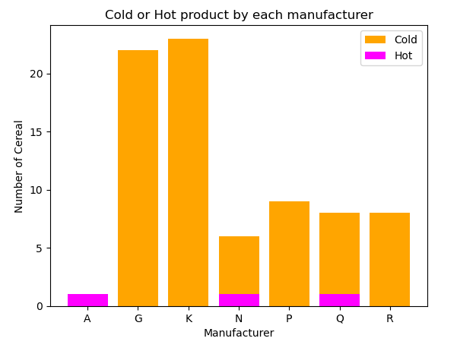Figure 4: Cold and hot products by each manufacturer.

In contrast to Nabisco and Quaker Oats, who provide both hot and cold cereals, Figure 4 demonstrates that "American Home Food Products" solely offers hot cereal. The remaining producers solely provide cold cereal. There are just three distinct hot cereal varieties, compared to 74 different cold cereal varieties. According to these numbers, cold cereals are far more popular than hot cereals.

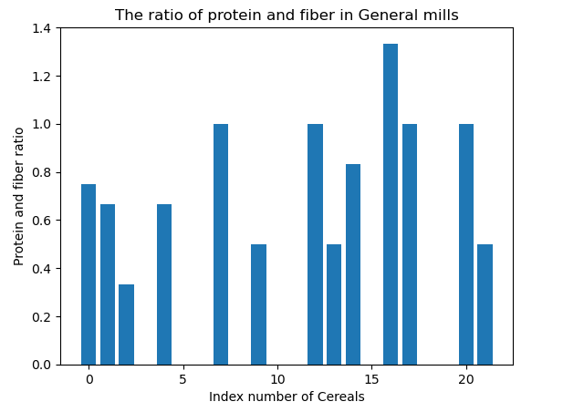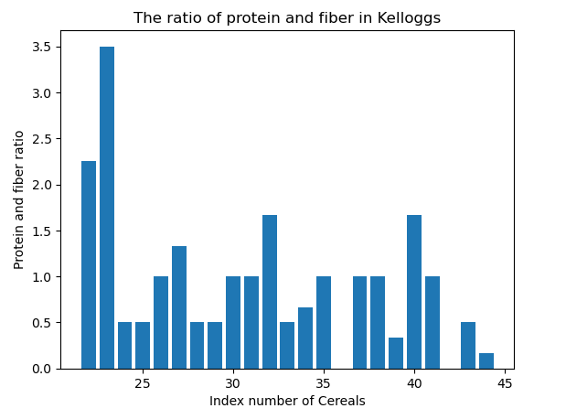 (a) (b)

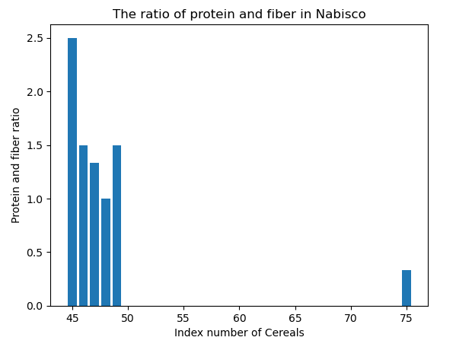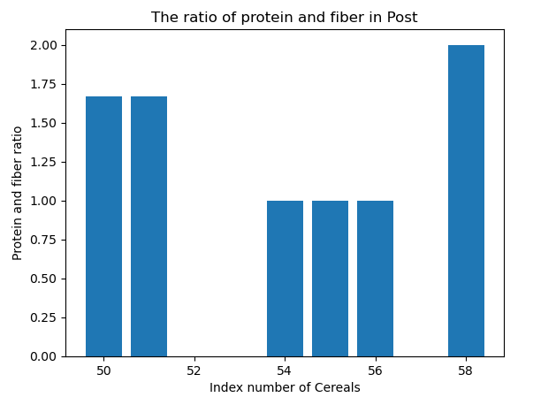 (c) (d)

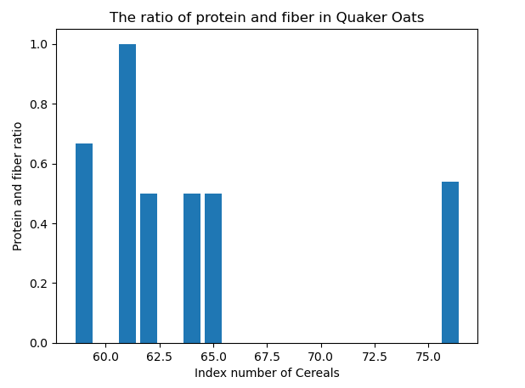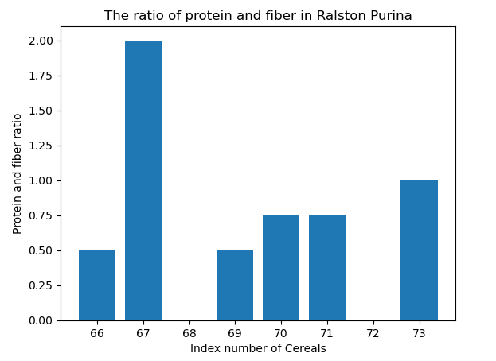 (e) (f)

Figure 5: The ratios of Protein and Fiber in cereals of (a) General Mills, (b) Kelloggs, (c) Nabisco, (d) Post, (e) Quaker Oats, (f) Ralston Purina

According to a research, those who followed a high-fiber, high-protein diet lost more body weight than people who did not. Yet a high-fiber, high-protein diet has advantages that go beyond just helping to loose weight. For instance, protein is crucial for the synthesis of skin, cartilage, bones, and muscles [1]. In order to determine which cereals from which manufacturer have a high protein and fiber ratio, the data on the protein and fiber ratio was examined. Figure 5 demonstrates that practically all of the protein to fiber ratios in Quaker oats and Ralston Purina cereals are less than one (0x1), but Nabisco cereals have a high protein to fiber ratio with almost all values larger than one and fewer than 2.5. For the cereals from Post, when this ratio is larger than 1 and less than 2, the situation is different. There are high-fiber, high-protein cereals from General Mills and Kellogg's as well as low-fiber, low-protein cereals.

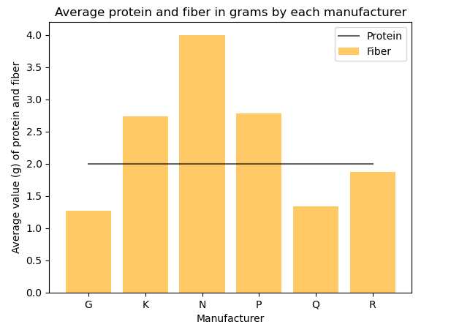Figure 6: Average protein and fiber in cereals of each manufacturer

Figure 6 shows that the average fiber in Kelloggs, Nabisco, and Post is higher than 2 grams where the others have less than 2 grams. Figure 6 demonstrates that whereas the other brands contain less than 2 grams of fiber on average, Kellogg's, Nabisco, and Post have more than 2 grams. On the other hand, the manufacturer's cereals typically contain average 2 grams of protein.

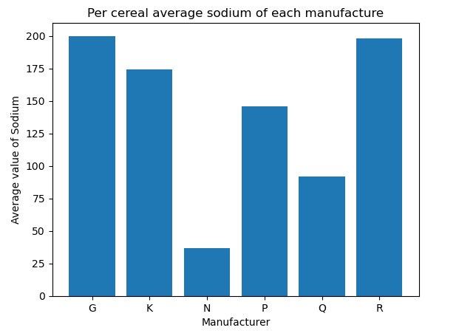Figure 7: Average sodium (g) in cereals of each manufacturer

The average American consumes around 1 gram more salt than what is advised by the Institute of Medicine to maintain a healthy blood pressure level, which is 2.3 grams per day. Choosing cereals that are salt-free or low in sodium will help to remain below the recommended amount of sodium for the day. Beginning the day with more than 10% of the upper intake of sodium will make it harder to do so [2]. According to the graph in figure 7, Quaker Oats and Nabisco Manufacturer offer cereal with less than 100mg of salt per serving. But, the cereals made by the other producers have more salt in them over 150g per serving.

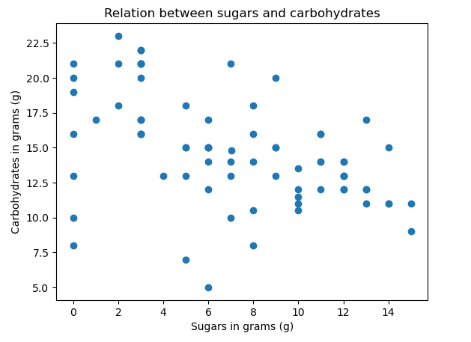Figure 8: Carbohydrates and sugars relation

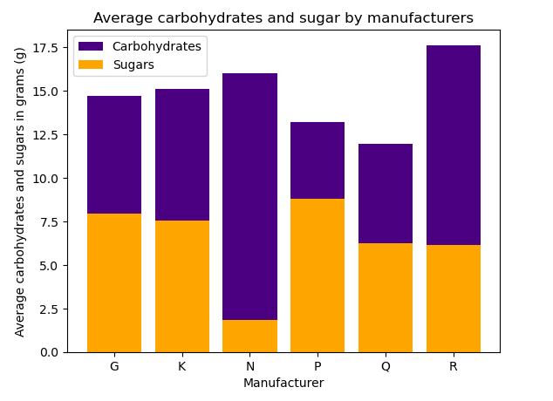Figure 9: Average carbohydrates and sugars in cereals of each manufacturer

Depending on the person's activity level and health objectives, cereal should have the ideal quantity of both sugars and carbohydrates. In order to enhance general health and wellbeing, it is crucial to pick cereals that offer a mix of good sugars and carbohydrates. In the instance of this cereal dataset analysis, consumers can be advised to eat the right cereal based on their health status. This study looked into the relationship between the sugars and carbohydrates found in cereals. Nevertheless, as illustrated in figure 8, no association between sugars and carbohydrates was seen. Figure 9 demonstrates that only Nabisco offers low sugars, which are less than 2.5 grams per serving, as opposed to other manufacturers that offer sugars of around 7.5 grams. On the other side, each brand offers high carbohydrate cereals, ranging from 12 to 17.5 grams per serving.

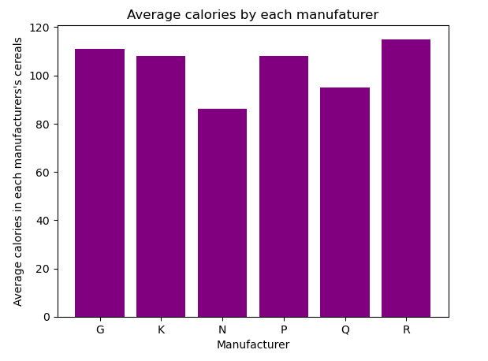Figure 10: Average calories in cereals of each manufacturer

The average number of calories in cereals produced by each company is shown in Figure 10, where it is clear that all manufacturers adhere to a minimum number of calories per serving. Nonetheless, Ralston Purina's and Nabisco's cereals have the most and the least calories, respectively.

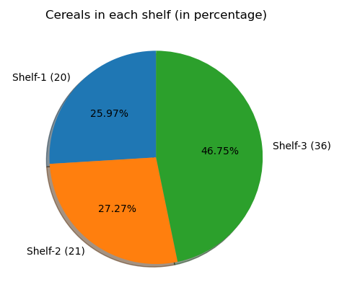Figure 11: Proportion of cereal in each shelf

Three shelves held all of the cereals in this dataset. Figure 11 depicts the quantity of cereals kept on each shelf. While cereals are located on shelves 1 and 2 in quite close proximity with only one variation in number between them. However, shelf 3 has the largest number and shelf 2 the lowest number of cereals.

**References**

[1] O. Artyshchuk, “Fiber and Protein: Why a High Protein High Fiber Diet Will Change Your Life - Community Health Network - Blog,” *Community Health Network*, Mar. 30, 2022. https://mychn.org/fiber-and-protein/ (accessed Feb. 19, 2023).

[2] “What Makes Cereals Unhealthy?,” *Healthy Eating | SF Gate*. https://healthyeating.sfgate.com/cereals-unhealthy-3637.html (accessed Feb. 19, 2023).